Pyrenophora
Facesoffungi number: FoF 000009

Citation:
Ariyawansa HA, Kang JC, Alias SA, Chukeatirote E, Hyde KD. 2014b - Pyrenophora. Current Research in Environmental & Applied Mycology (In press)

Pyrenophora Fr., Summa veg. Scand., Section Post. (Stockholm): 397 (1849). MycoBank: MB 4596
= Drechslera S. Ito, Proc. Imp. Acad. Japan 6: 355 (1930)
Sexual state: Ascomata immersed, becoming erumpent to near superficial, solitary or scattered, globose to subglobose, broadly or narrowly conical, smooth-walled, ostiolate. Ostiole papillate, covered with brown to reddish-brown setae, which are darkened at the base. Peridium comprising 2–4 layers of brown, thick-walled cells of textura angularis. Pseudoparaphyses not observed. Asci 8-spored, bitunicate, fissitunicate, clavate to sub-cylindrical, with a short, broad pedicel, with a distinct ocular chamber surrounded by a large apical ring. Ascospores 2–3-seriate, muriform, constricted at the septum, smooth-walled, surrounded by a mucilaginous sheath. Asexual state: hyphomycetous Conidiophores macronematous, mononematous, sometimes caespitose, straight or flexuous, often geniculate, unbranched or in a few species loosely branched, brown, smooth in most species. Conidiogenous cells polytretic, integrated, terminal, frequently becoming intercalary, sympodial, cylindrical, cicatrized. Conidia solitary, in certain species also sometimes catenate or forming secondary conidiophores which bear conidia, acropleurogenous, simple, straight or curved, clavate, cylindrical rounded at the ends, ellipsoidal, fusiform or obclavate, straw-coloured or pale to dark brown or olivaceous brown, sometimes with cells unequally coloured, the end cells then being paler than intermediate ones, mostly smooth, rarely verruculose, pseudoseptate (description of asexual state from Ellis 1971).
Type species: Pyrenophora phaeocomes (Rebent.) Fr., Summa veg. Scand., Section Post. (Stockholm): 397 (1849) MycoBank: MB 222199
= Sphaeria phaeocomes Rebent., Prodr. fl. neomarch. (Berolini): 338 (1804)
Notes: The genus Pyrenophora clusters in the suborder Pleosporineae of the family Pleosporaceae with a relatively high bootstrap support (Fig 1, 60%). Recent studies using multi-gene analysis and some coupled with morphology have provided the groundwork for classification of species in Pyrenophora (Sivanesan 1984, 1987, Berbee 1996, Zhang and Berbee 2001, Zhang et al. 2012, Hyde et al. 2013). Pyrenophora has been linked to asexual morphs in Drechslera. Drechslera species were initially categorized in Helminthosporium on the basis of their dark colour, transversely septate conidia and a graminicolous habitat (Shoemaker 1959). Consequently, graminicolous Helminthosporium species were segregated into three genera, Bipolaris, Drechslera, and Exserohilum, defined based on their association with their sexual states Cochliobolus, Pyrenophora, or Setosphaeria respectively (Zhang and Berbee 2001). Phylogenetic analysis (Fig. 2) shows that sexual Pyrenophora states cluster with asexual Drechslera states, i.e. Pyrenophora dictyoides (DAOM 75616) clusters with Drechslera dictyoides (DAOM 63666). The putative strain of Pyrenophora phaeocomes (DAOM 222769), which is the type species of the genus clusters with other Pyrenophora species and forms a sister clade with Drechslera biseptata. As a genus can now only have one name Drechslera was synonymized under Pyrenophora (Ariyawansa et al. 2014).

Phylogenetic placement of Pyrenophora in Pleosporaceae
Fig 1. RAxML tree based on based on the LSU, SSU and RPB2 sequences of 51 strains representing the Pleosporineae. Bootstrap support values >50% are shown above or below the branch. The tree is rooted to Trematosphaeria pertusa. The original isolate numbers are noted after the species names. Bold indicates extype strains.

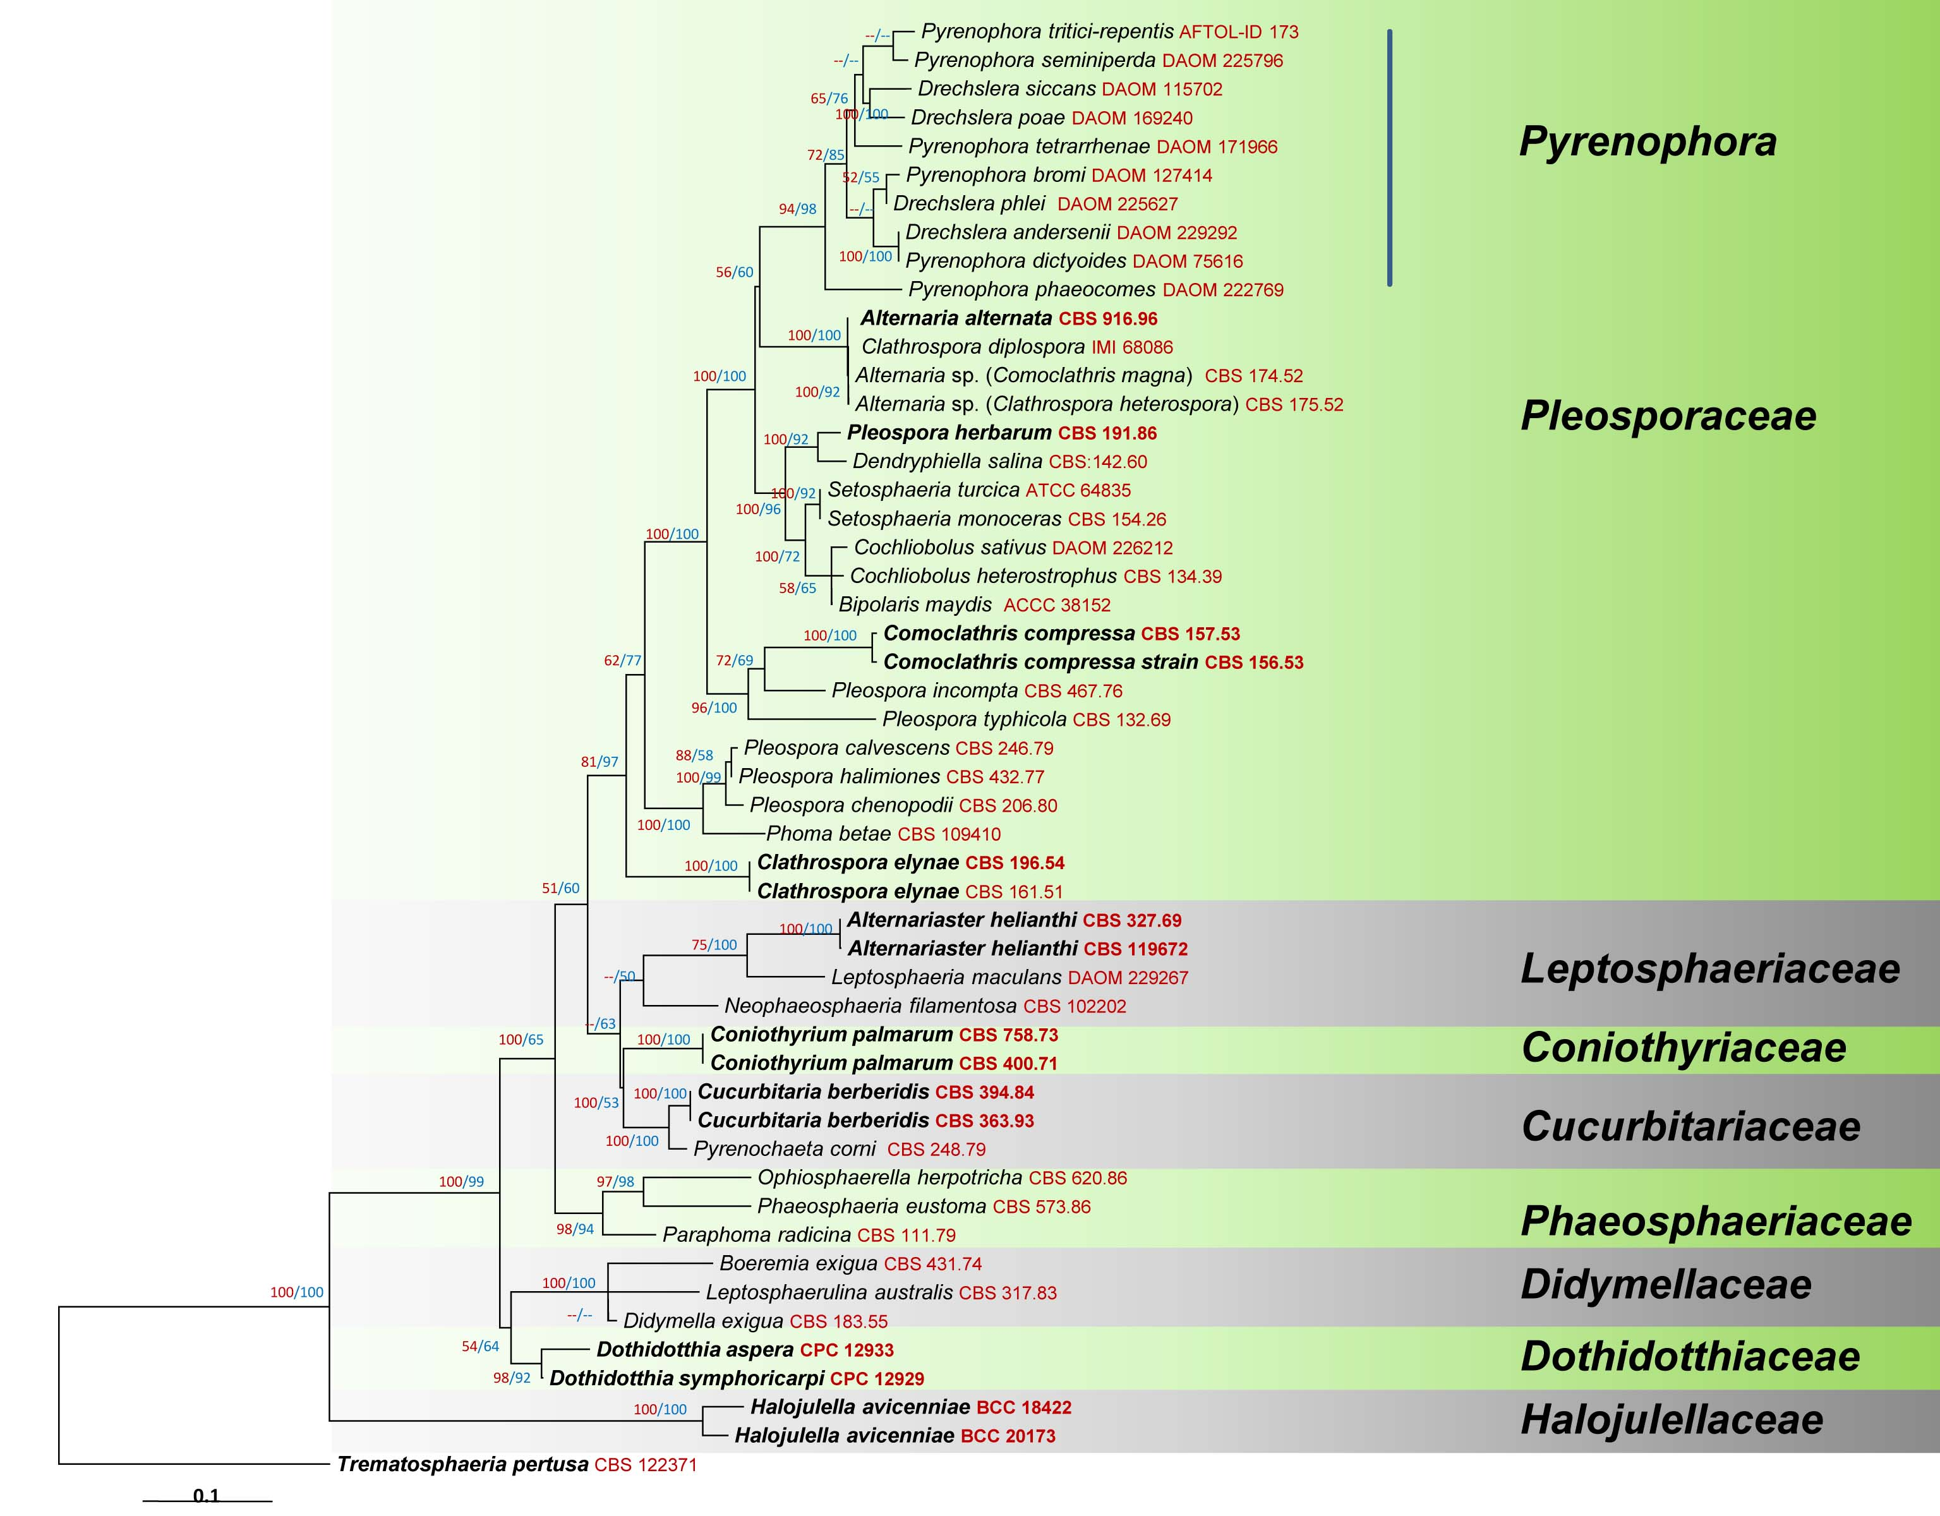
Importance and role
Pyrenophora species are phytopathogens, or as saprobes are involved in nutrient cycling. Many species cause disease on their graminicolous hosts and are usually present in their asexual state (Drechslera) (Zhang and Berbee 2001). Some species of Pyrenophora are serious plant pathogens (Zhang and Berbee 2001). Pyrenophora teres (Drechslera teres) is a necrotrophic pathogen of economically important crops, such as barley (Gupta and Loughman 2001, Kingsland 1991). Pyrenophora graminea (Drechslera graminea) causes barley stripe resulting in significant yield losses (Tekauz 1983). Pyrenophora graminea lives within barley kernels as mycelium, and when seeds germinate, hyphae enter the seedling through the coleorrhiza, causing a systemic infection (Pecchia et al. 1998, Leisova et al. 2005, Mokrani et al. 2012). Pyrenophora tritici-repentis causes tan spot of wheat (Lamari and Bernier 1989, Ballance et al. 1996) which occurs in all the major wheat growing areas of the world and causes 3 to 50% yield losses (Lamari and Bernier 1989) and its prevalence has increased recently. Pyrenophora avenae causes seedling blight of oats in different climatic zones (Motovilin, 2000). Because of the destruction of leaf tissue, photosynthesis is reduced in diseased plants, resulting in light or shriveled grains. Direct attack of kernels by the fungus also results in light or shriveled kernels. Severe disease attacks have caused yield losses as high as 30-40 percent (Motovilin & Strigekozin, 2000).

Industrial relevance
Some Pyrenophora species have been used as biocontrol agents. Bromus tectorum is a dominant winter annual weed in cold deserts of the western United States. (Meyer et al. 2007). Bromus tectorum and other annual brome grasses have invaded many ecosystems of the western United States, and because of an annual-grass influenced alteration of the natural fire cycle on arid western range lands near monocultures are created and conditions in which the native vegetation cannot compete have been established (Meyer et al. 2007).

Biosecurity
Drechslera cactivora (stem rot and fruit rot on Cactus species), Drechslera curvispora, Drechslera gigantean, Drechslera longirostrata (seed rot), Drechslera maydis (Southern corn blight), Drechslera musae-sapientium (leaf spot), Drechslera nodulosa (seed rot), Drechslera patereae, Drechslera pedicellata (root rot), Drechslera sorghicola (grain mould), Drechslera stenospila (leaf spot), Pyrenophora cerastii, Pyrenophora chrysospora and Pyrenophora tetramera (net blotch) are listed in New Zealand Ministry for Primary Industries as unwanted organisms(http://www.biosecurity.govt.nz/ Accession Date – 2 April 2014).

Biochemistry
A new phytotoxic sesquiterpenoid penta-2,4-dienoic acid, named pyrenophoric acid, was isolated from solid wheat seed culture of Pyrenophora semeniperda, which is a fungal pathogen proposed as a mycoherbicide for bio-control of cheat grass (Bromus tectorum) and other annual bromes (Masi et al. 2014). This genus should be assessed for its chemical diversity and novel compounds.

Phylogenetic placement of Pyrenophora species
Fig. 2. RAxML tree based on a combined dataset of ITS, LSU and GPDH. Bootstrap support values >50% are shown above or below the branch. The tree is rooted with Pleospora herbarum. The original isolate numbers are noted after the species names. Bold indicates ex-type strains.
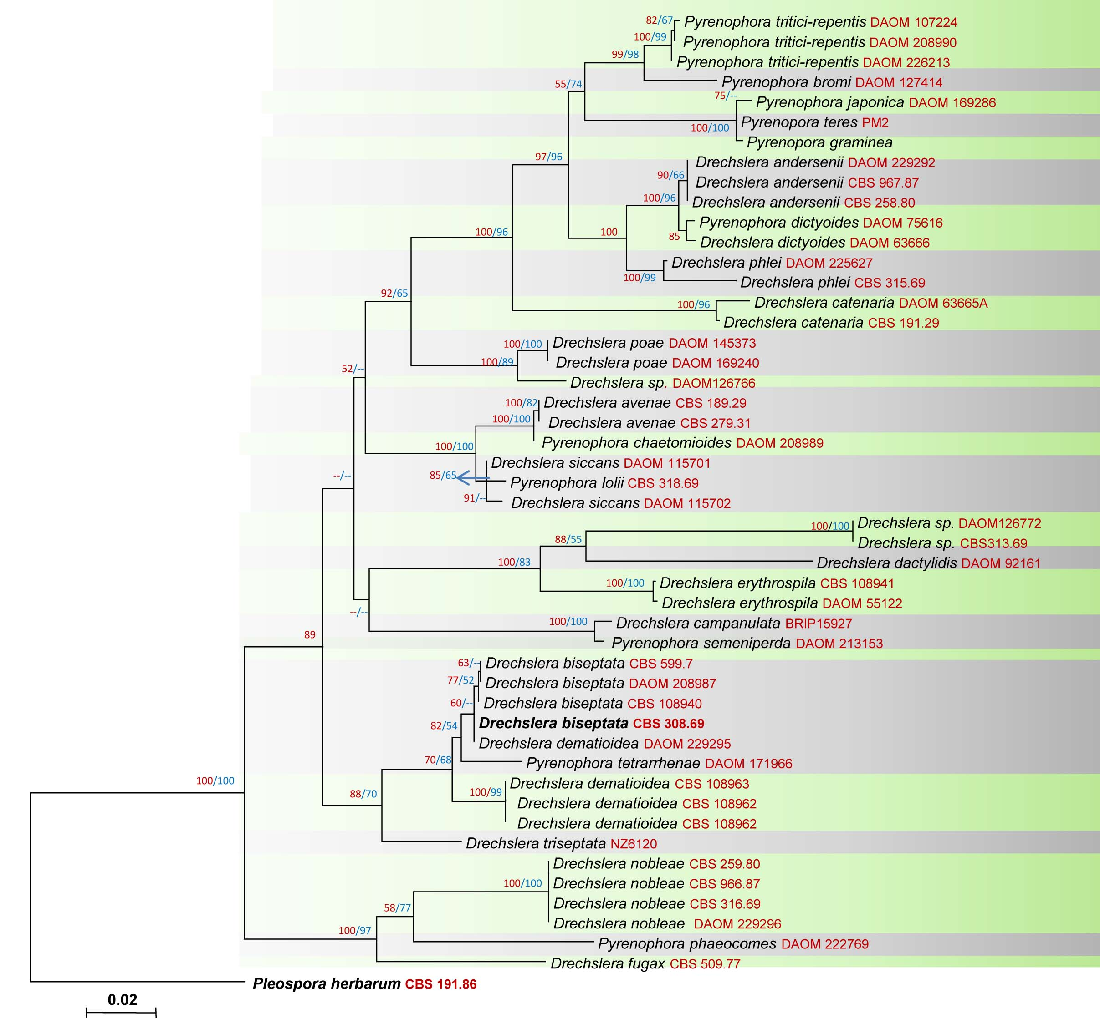
References
Ariyawansa HA, Kang JC, Alias SA, Chukeatirote E, Hyde KD. 2014 – Pyrenophora. Current Research in Environmental & Applied Mycology (In press)
Ballance GM, Lamari L, Kowatsch R, Bernier CC. 1996 – Cloning, expression and occurrence of the gene encoding the Ptr necrosis toxin from Pyrenophora tritici-repentis. Molecular Plant Pathology On-Line [http://www.bspp.org.uk/mppol/] 1996/1209ballance
Berbee ML. 1996 – Loculoascomycete origins and evolution of filamentous ascomycete morphology based on 18s rrna gene sequence data. Molecular Biology and Evolution 13(3), 462–470
Ellis MB . 1971 – Dematiaceous hyphomycetes. Commonwealth Mycological Institute, Kew
Gupta S, Loughman R. 2001 – Current virulence of Pyrenophora teres on barley in Western Australia. Plant Disease 85(9), 960–966.
Hyde KD, Jones EBG, Liu JK, Ariyawansa HA, Boehm E, Boonmee S, Braun U, Chomnunti P, Crous PW, Dai DQ, Diederich P, Dissanayake AJ, Doilom M, Doveri F, Hongsanan S, Jayawardena R, Lawrey JD, Li YM, Liu YX, LÜCking R, Monkai J, Muggia L, Nelsen MP, Pang KL, Phookamsak R, Senanayake I, Shearer CA, Seutrong S, Tanaka K, Thambugala KM, Wijayawardene DNN, Wikee S, Wu HX, Zhang Y, Aguirre-Hudson B, Alias SA, Aptroot A, Bahkali AH, Bezerra JL, Bhat JD, Camporesi E, Chukeatirote E, Gueidan C, Hawksworth DL, Hirayama K, De Hoog S, Kang JC, Knudsen K, Li WJ, Li X, Liu ZY, Mapook A, McKenzie EHC, Miller AN, Mortimer PE, Phillips AJL, Raja HA, Scheuer C, Schumm F, Taylor JE, Tian Q, Tibpromma S, Wanasinghe DN, Wang Y, Xu J, Yan J, Yacharoen S, Zhang M. 2013 – Families of Dothideomycetes. Fungal Diversity 63, 1–313
Leisova L, Kucera L, Minarikova V, Ovesna J. 2005 – AFLP-based PCR markers that differentiate spot and net forms of Pyrenophora teres. Plant Pathology 54(1), 66–73.
Masi M, Meyer S, Cimmino A, Andolﬁ A, Evidente A. 2014 – Pyrenophoric acid, a phytotoxic sesquiterpenoid penta-2,4 dienoic acid produced by a potential mycoherbicide, Pyrenophora semeniperda. Journal of Natural Products, on line.
Meyer S.E, Quinney D, Nelson DL, Weaver J. 2007 – Impact of the pathogen Pyrenophora semeniperda on Bromus tectorum seed bank dynamics in North American cold deserts. Weed Research 47: 54–62
Mokrani L, Jawhar M, Shoaib A, Arabi MIE. 2012 – Characterization of Pyrenophora graminea Markers associated with a Locus Conferring Virulence on Barley. Plant Pathology 28 (3), 290–294.
Motovilin AN. 2000 – Responsiveness of oats varieties on fungicides application against red-brown spot. Protection and Quarantine of Plants 10, 30.
Motovilin AN, Strigekozin JA. - 2000. Estimation of oats basic disease harmfulness. Protection and Quarantine of Plants 7, 28.
Pecchia S, Mercatelli E, Vannacci G. 1998 – PCR amplification and characterization of the intergenic spacer region of the ribosomal DNA in Pyrenophora graminea. FEMS Microbiology 166(1), 21–27.
Sivanesan A. 1984 – The Bitunicate Ascomycetes and their Anamorphs. J. Cramer, Vaduz
Sivanesan A. 1987 – Graminicolous species of Bipolaris, Curvularia, Drechslera, Exserohilum and their teleomorphs. Mycological Papers 158, 1–261
Tekauz A. 1983 – Reaction of Canadian barley cultivars to Pyrenophora graminea, in the incident of leaf stripe. Canadian Journal of Physiology and Pharmacology 5, 294–301.
Zhang G, Berbee ML. 2001 – Pyrenophora phylogenetics inferred from ITS and glyceradehyde-3-phosphate dehydrogenase gene sequences. 93(6), 1048–1063
Zhang Y, Crous PW, Schoch CL, Hyde KD. 2012 – Pleosporales. Fungal Diversity 53, 1–221

Contributors:
Ariyawansa HA^{1,2,3}, Kang JC¹, Alias SA⁴, Chukeatirote E^{2,3}and Hyde KD^{2,3,5,6}
¹The Engineering and Research Center for Southwest Bio-Pharmaceutical Resources of National Education Ministry of China, Guizhou University, Guiyang 550025, Guizhou Province, China
²School of Science, Mae Fah Luang University, Chiang Rai. 57100, Thailand
³Institute of Excellence in Fungal Research, Mae Fah Luang University, Chiang Rai 57100, Thailand
⁴Institute of Biological Sciences, University of Malaya, 50603, Kuala Lumpur
⁵Centre for Mountain Ecosystem Studies (CMES), Kunming Institute of Botany, ⁸Chinese Academy of Science, Kunming 650201, Yunnan, China
⁶World Agroforestry Centre, East Asia Office, Kunming 650201, Yunnan, China
Authors for correspondence (jichuank@yahoo.co.uk; kdhyde3@gmail.com)

